### February 12, 2014

### 12:10 PM

## Meeting 1

# KissingBug.com

1. Future meetings   
     
   Weekly: on Wednesday(s)   
   Time: 12:10 PM   
   Location: Veterinary Medical Research Building

*Yolanda McDonald  
Rachel Curtis   
Jannel Gonzales*

* Established future meeting times
* General goals for the estimated timeline
  + Part 1
  + Part 2
* Part 1 – Base map
* Part 1 – Database columns
* Part 1 – Information display
* Part 2 – Drop down list(s)
* Part 2 – Time Series slider display
* Part 2 – Time series graphs (month by month line graph)

1. General Goals for the Timeline:   
   10 weeks between This week (Feb. 12) - April   
   **Part 1** - Set up static display:   
   a base map, the database design, a counties polygon layer and code for the website page to display the base map with a test –information- display when polygons are clicked  
   **Part 2** - Add filtering and dynamic elements:   
   - drop down (filtering) lists to specify which data points the map displays  
   - Time series display slider & “auto-populated line graphs” for month by month count of bugs ____either collected or infected___ by counties where bugs have been collected/tested under the map??   
   - Also, finalize the detailed information windows with the real data being displayed
2. Part 1 - Base map:  
   Texas ________,   
   County boundaries layer,   
   no Lat\Long grid displayed,   
   Major cities labeled   
     
   FINAL “DEFAULT LOADED” MAP will display ALL data points of county bug total(s) in the information windows
3. Part 1 - Database columns:   
   Codename_bug   
   UniqueID number,   
   Bug Species name,   
   County,   
   Month,   
   Year,   
   ****Status (1 = infected or 0 = not infected),   
   ****Tested (1 = yes or 0 = not tested)
4. Part 1 – Information display:  
   We received the test database information – will need possible revisions to the “Infected” and missing “Tested” columns; it would be ideal to have 0 or 1, instead of text Yes or No  
   However – for now the plan is to have a display like this pop up when you click on a county polygon
5. Part 2 – Drop-down list(s)  
   Bug species   
    A example  
    B kissing  
    C bugs  
    D names  
    or ALL (which is the default)  
   Status  
    Infected Bugs  
    Non-infected bugs
6. Part 2 - Time series slider
7. Part 2 - Time series graphs   
   Generate code to create a graph from all counties where # records != 0

SEE <http://soilmoisture.tamu.edu/> and <http://soilmoisture.tamu.edu/Data/Map/> for screen shots below   
Added them to reference to when we decide what time-filtering element we want to use.

Home Page 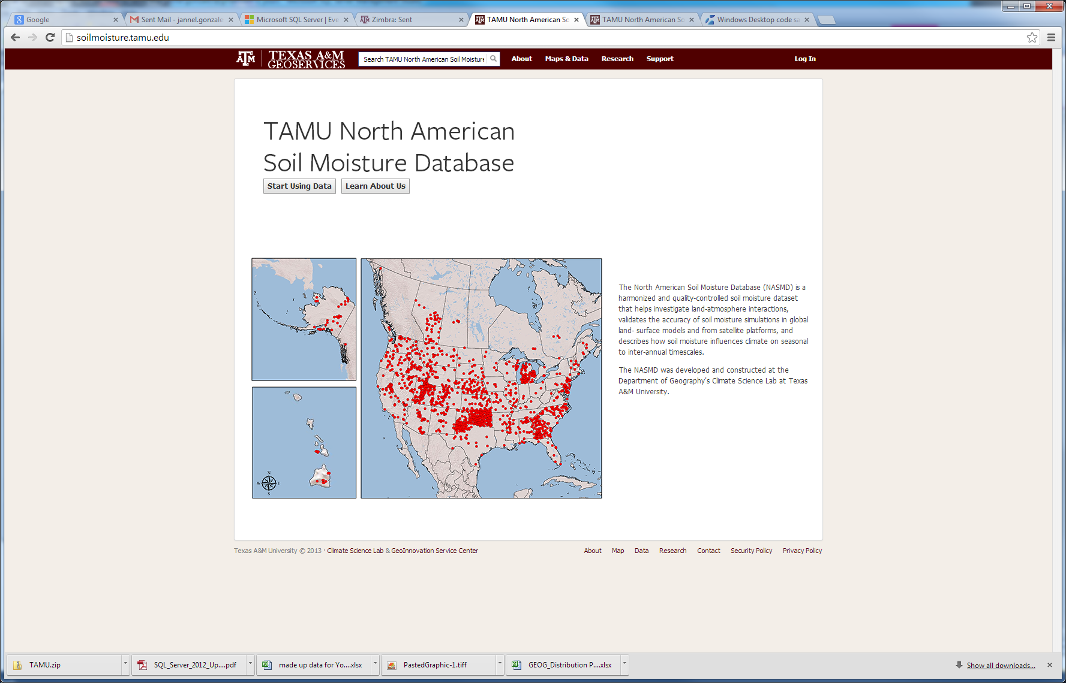  
  
About tab…

Maps & Data tab….. or Start Using Data button from home screen…..  
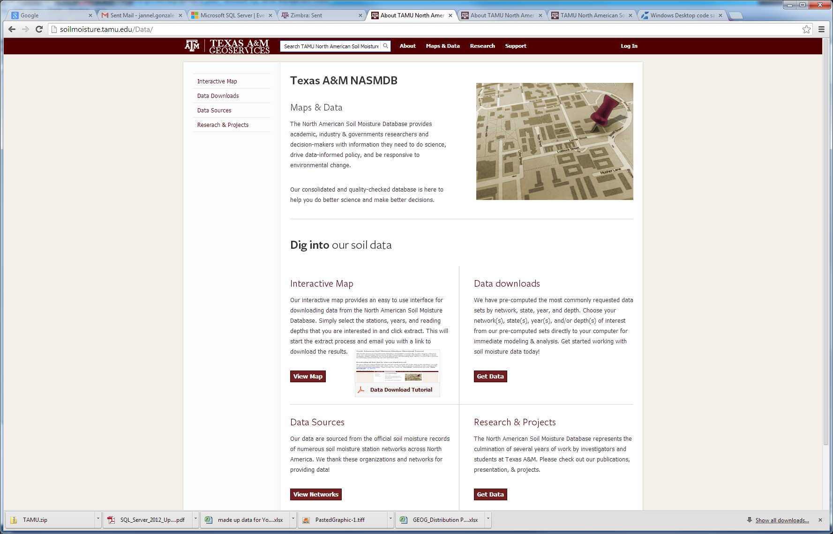

Research tab…. 

Support tab…   
Log-in page….

Interactive Map…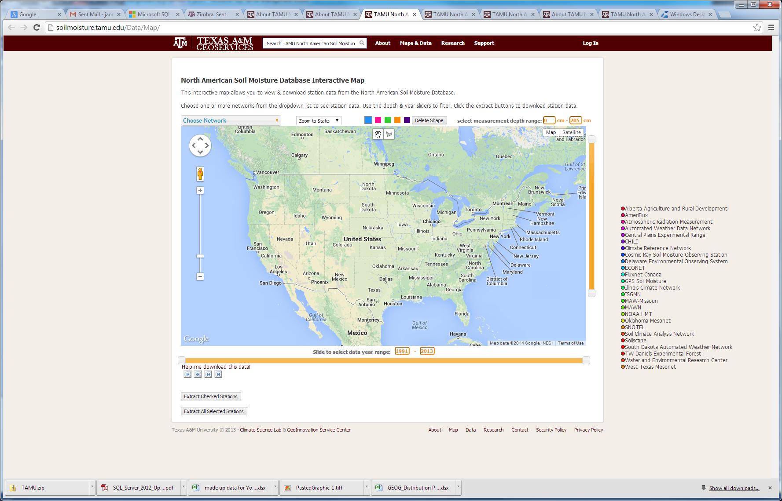

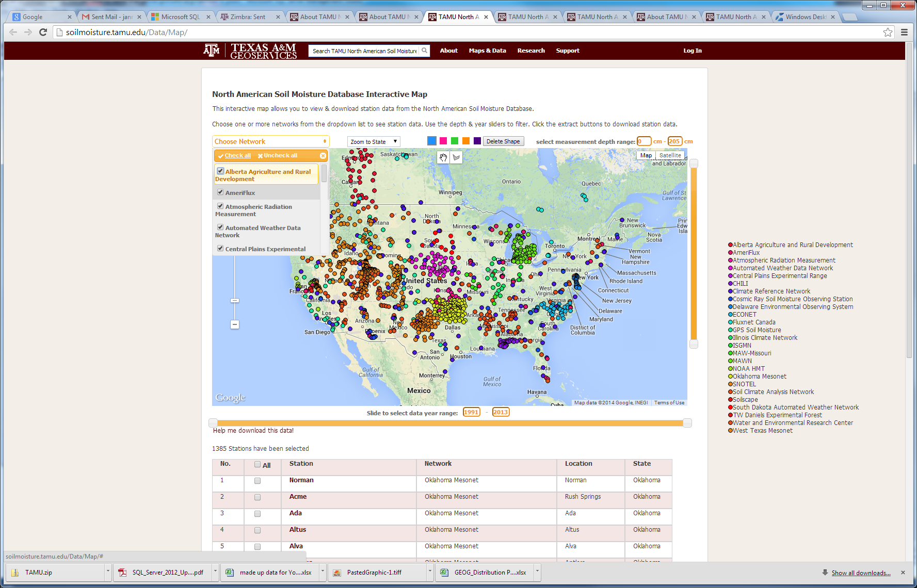

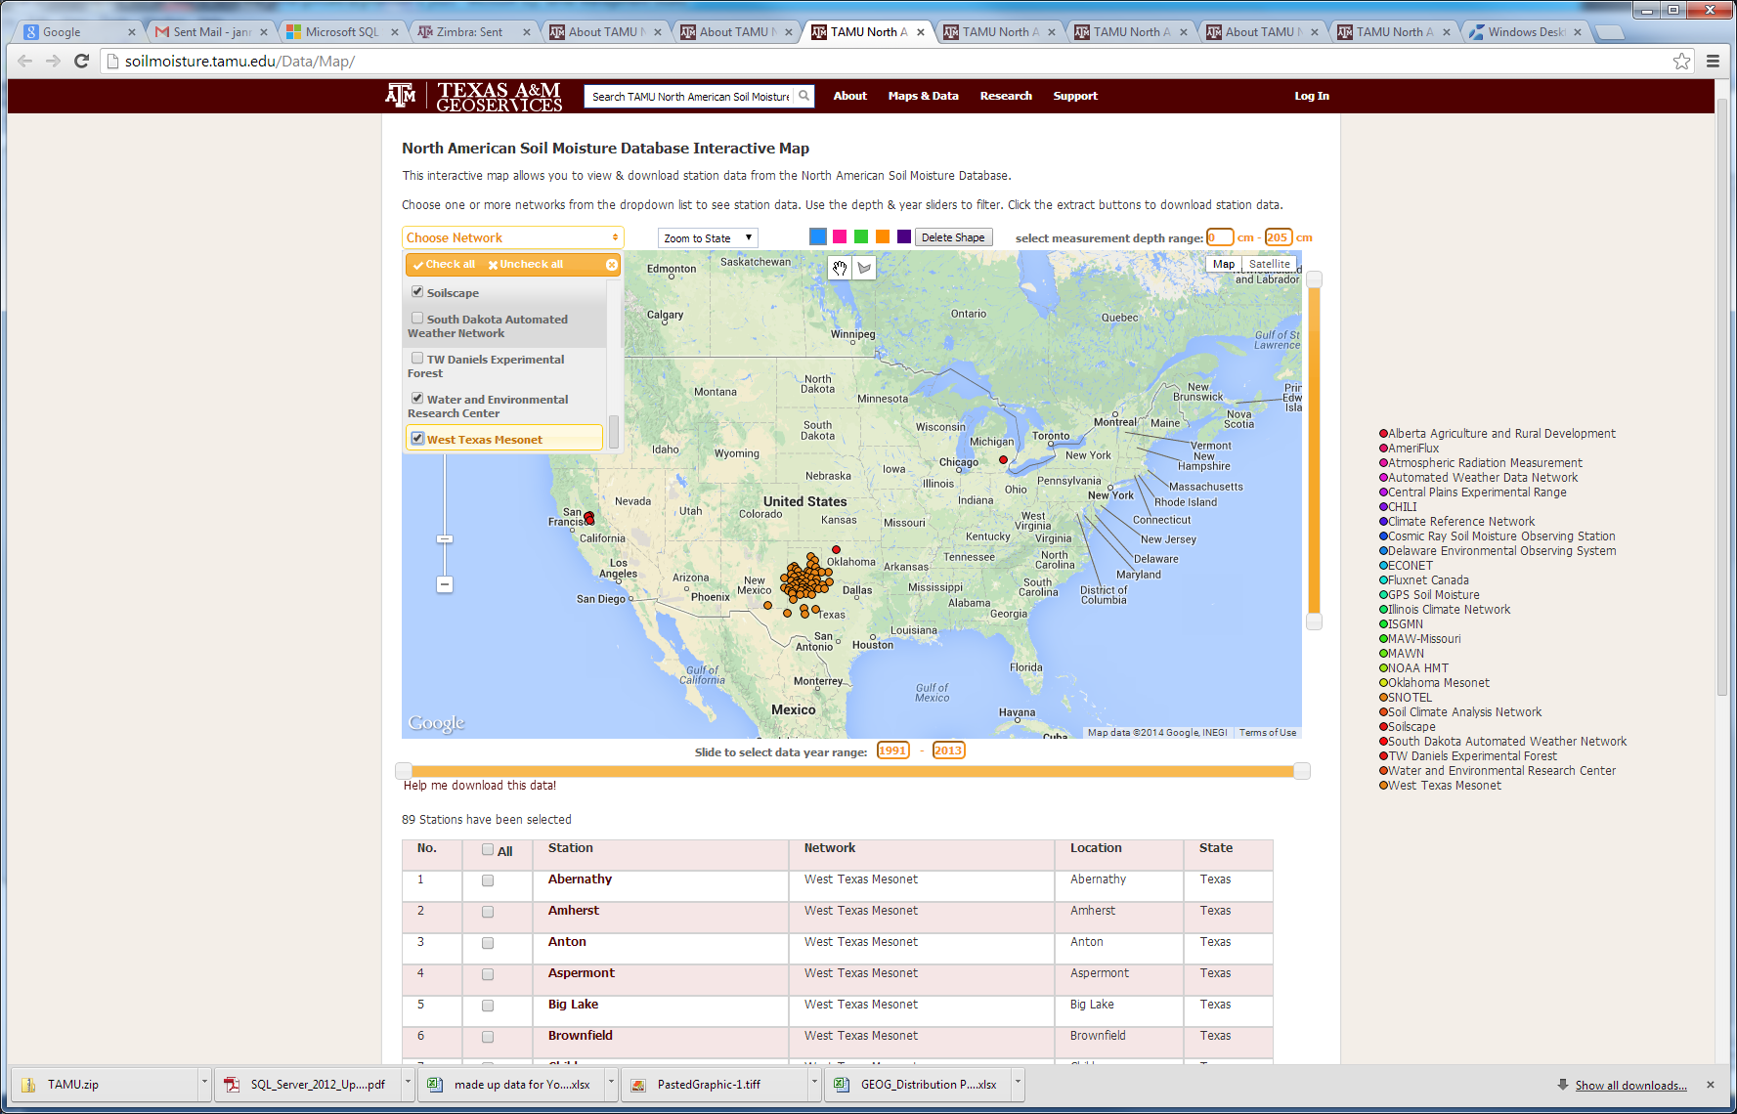

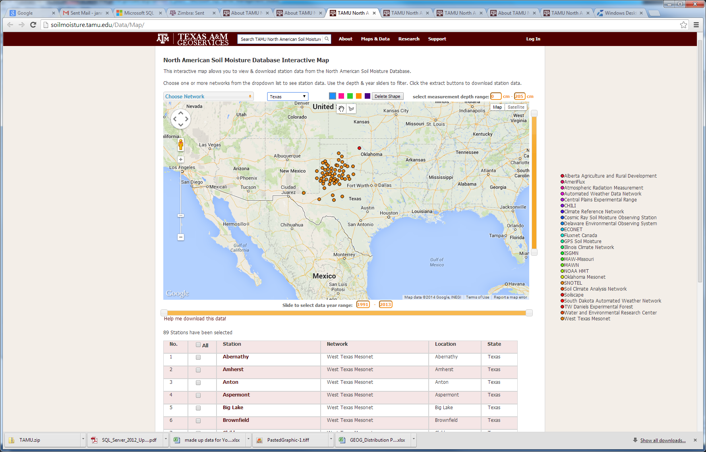

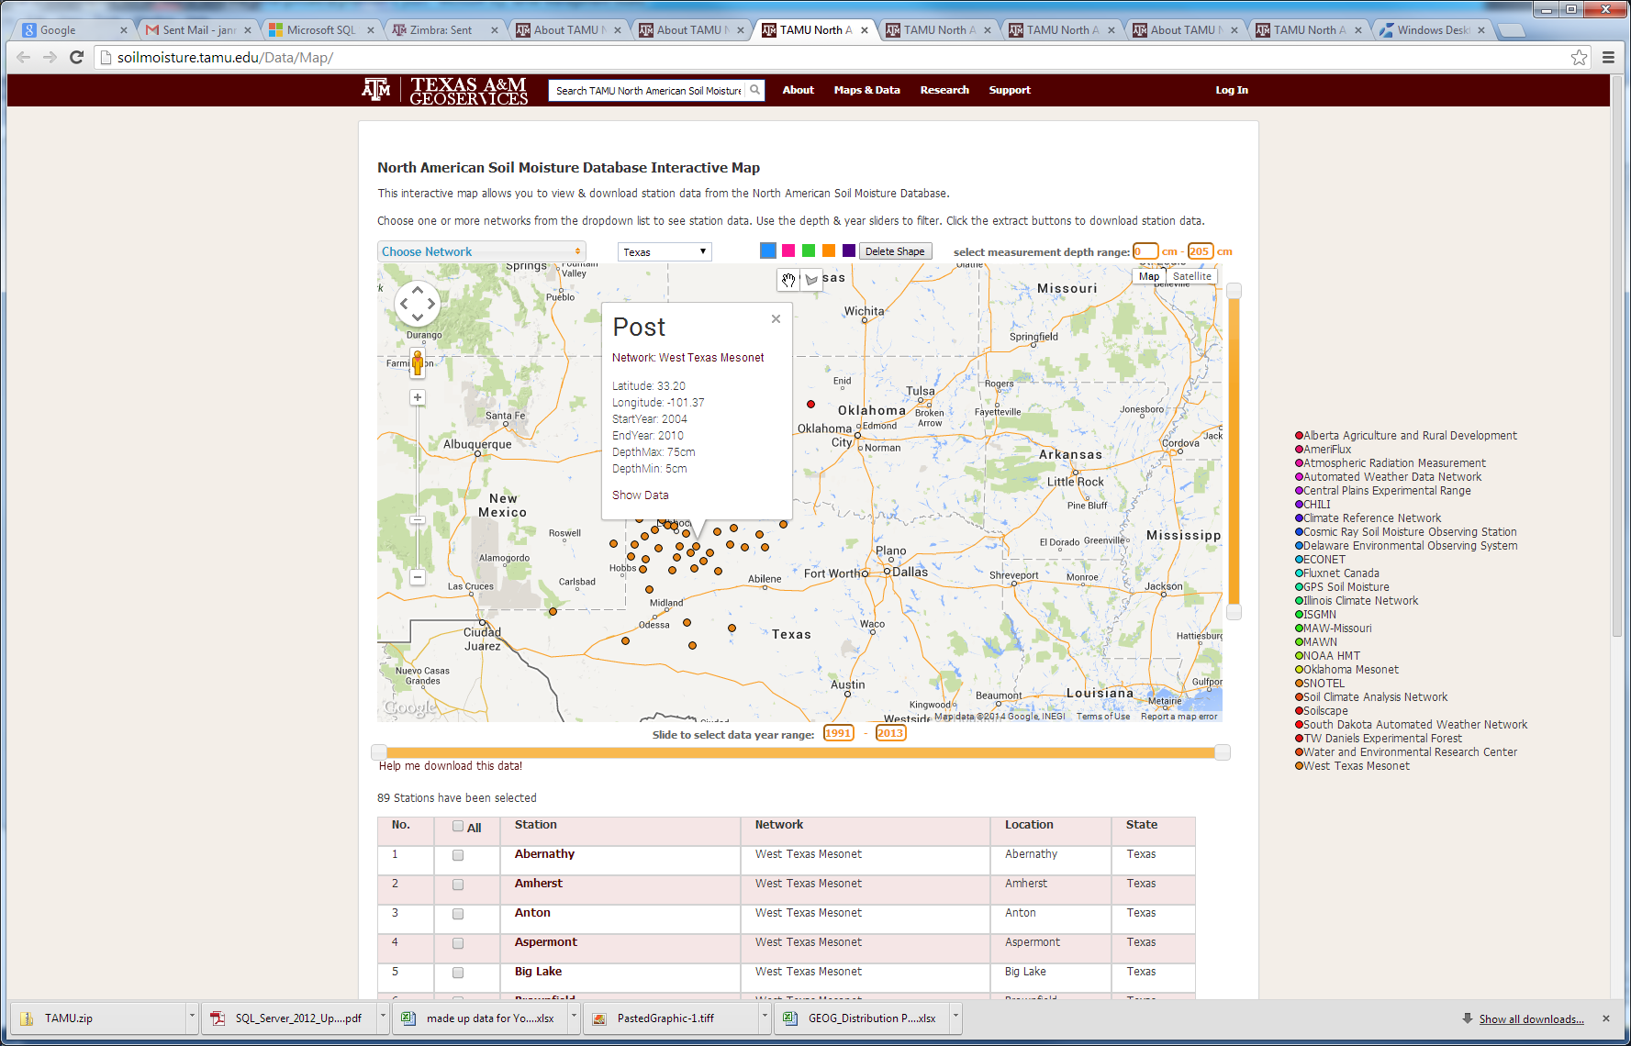

Show data button in pop up …….   
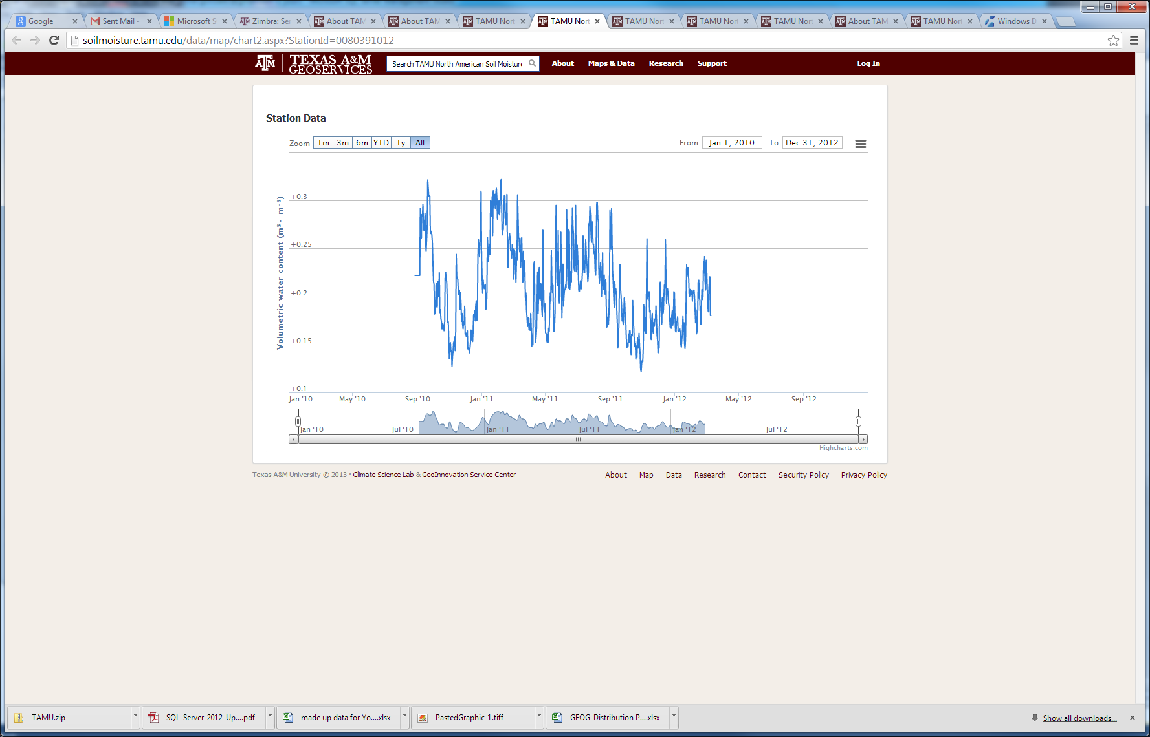  
  
Data downloads link….  
